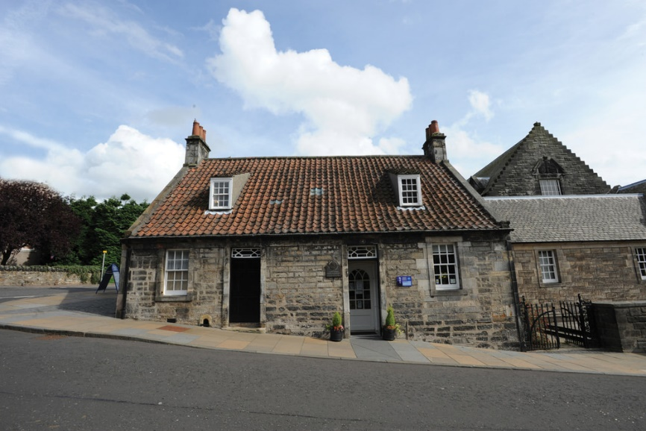
View of the Birthplace Museum

Venue Accessibility Guide

We aim to make your visit to the Andrew Carnegie Birthplace Museum as accessible and enjoyable as we can.
If you require any more information related to the museum’s accessibility that is not included, or have any ideas about improvements should make, please contact info@carnegiebirthplace.com or call us on 01383 724302.

Contents
Building Layout 3
Arrival and Welcome (inc. Covid 19 Changes) 4
Reception and Shop Area 9
Who you may meet – Our Staff 10
Toilet Facilities 10
Garden and Assistance Dog Facilities 15
Indoor Refreshment and Play Areas 16
Visitor Route 17
Birthplace Cottage 17
Museum Hall 22
Sensory Triggers 23
Emergency Evacuation Procedures 23

Building Layout

There are two public entry / exit points. The main entrance is marked on the right, the side entrance with level access on the bottom. The side entrance is usually locked for security reasons.
We have provided a floorplan of the museum below to help visitors orientate themselves before coming. The museum compromises three main parts – the Birthplace cottage over two floors, the museum hall, and the adjoining toilet block which is accessible through the garden.
Level Fire Exit
Fire Exit
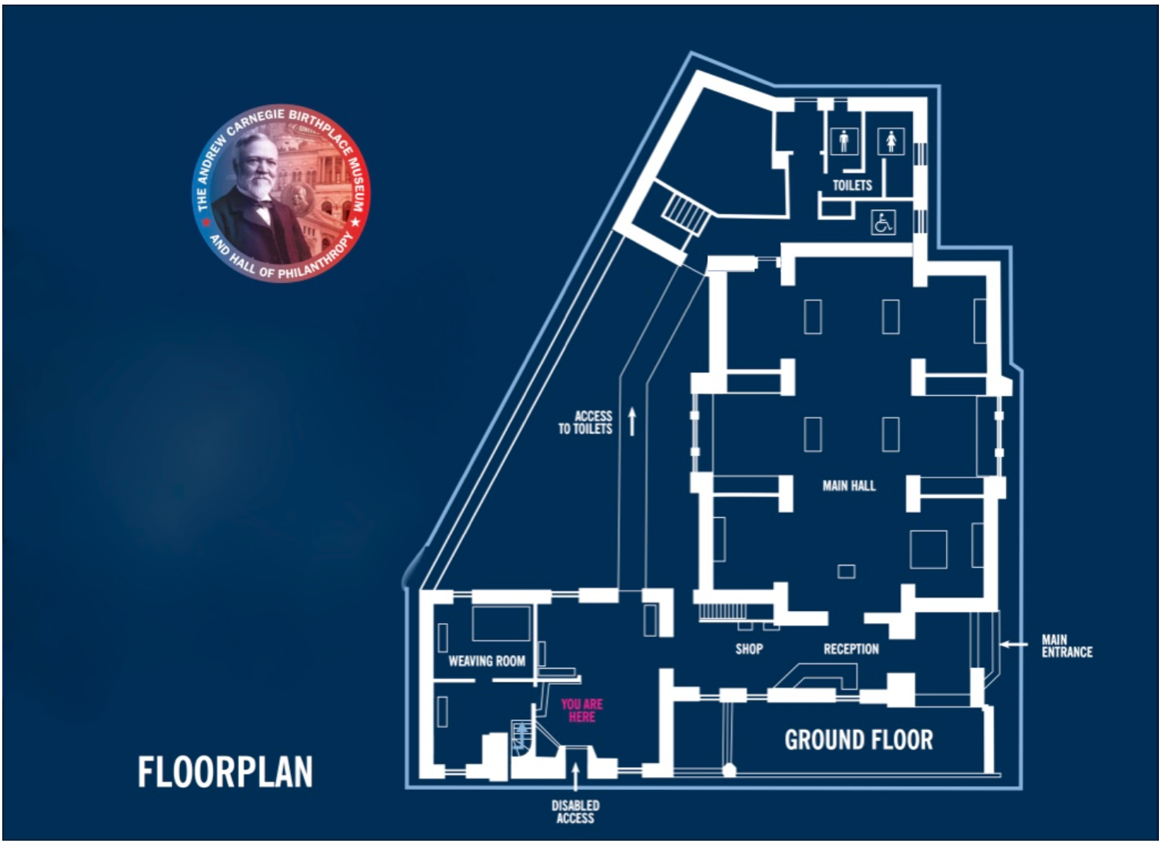
Upstairs Fire Exit
Fire Exit

Arrival and Welcome
Covid 19 Changes
In response to the ongoing public health crisis, we have introduced several changes to protect our staff and visitors. This includes:
- The museum now operates a booking system, with timed entry every 20 minutes. Each ticket covers up to 8 people from the same household. Tickets can be booked here.
- Due to the small size of the cottage, only one household is allowed into this part of the building at a time. This allows enough space for social distancing from other groups.
- Visitors are asked to adhere to the new one-way system by following floor stickers. There is a barrier up the shop aisle, with approx. 80cm space on each side.
- 4 sanitiser stations at key points around the museum, including on arrival and in the toilet block. Each sanitizer station is approximately 1 metre from the floor level.

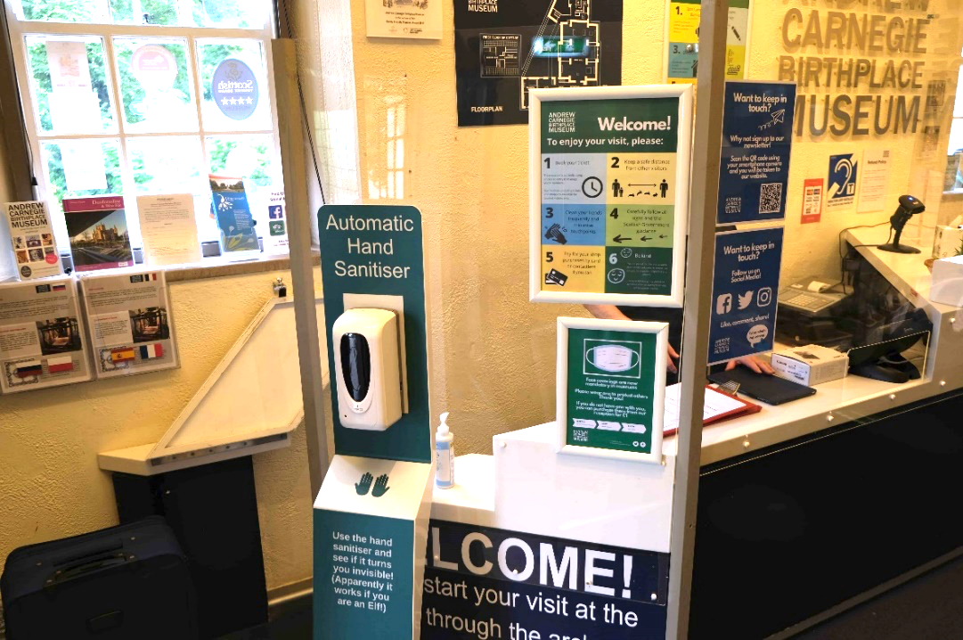

Example of new hand sanitiser stations.
- We have kept our accessible toilet open for visitors.
- Temporary removal of several children’s hands-on activities, such as costumes and activity bags. We have kept some activities including our trails and bunny hunt.
- Face coverings are now mandatory in museums, but we have some Euan’s Guide ‘Exempt’ lanyards available at the front desk for those unable to wear a mask for any medical reason.
- Encouragement of contactless payments where possible.
- Implementation of regular cleaning throughout the day, especially of high-risk touch points.
- We have temporarily paused our events programme. We will resume this in line with governmental advice and when safe to do so.

For more information, please see our FAQS page.

Main Entrance
- There is no intercom or call button required to gain access to the building through the main entrance.
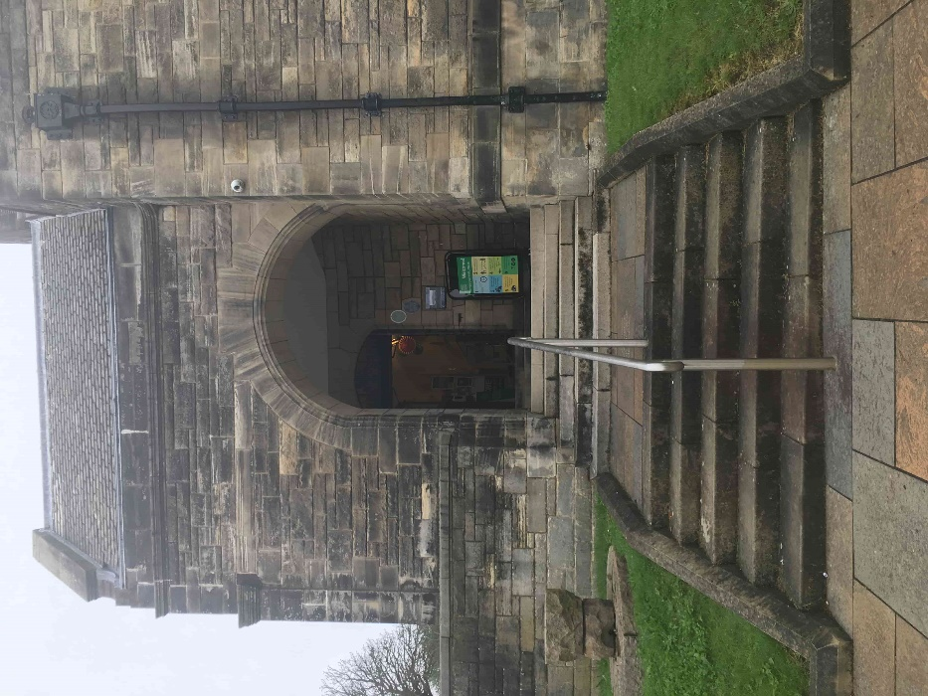

- There are 12 steps from the pavement to the entrance, the bottom section has a handrail (see above)
- The main door is motion sensitive and opens automatically. The main door makes a beeping sound when it opens.

- There is a new sign displaying some of the Covid-19 changes we have introduced (see below)

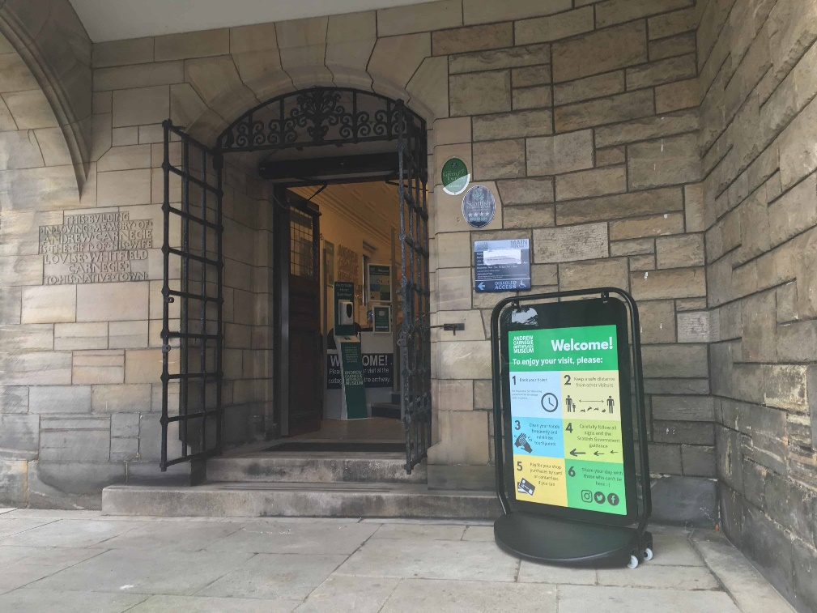
- The narrowest point is 95cm wide.
- There are additional 2 steps to the reception desk.
There are fewer steps, 4 in total, to the main entrance if you are approaching via the side gate along the terrace.

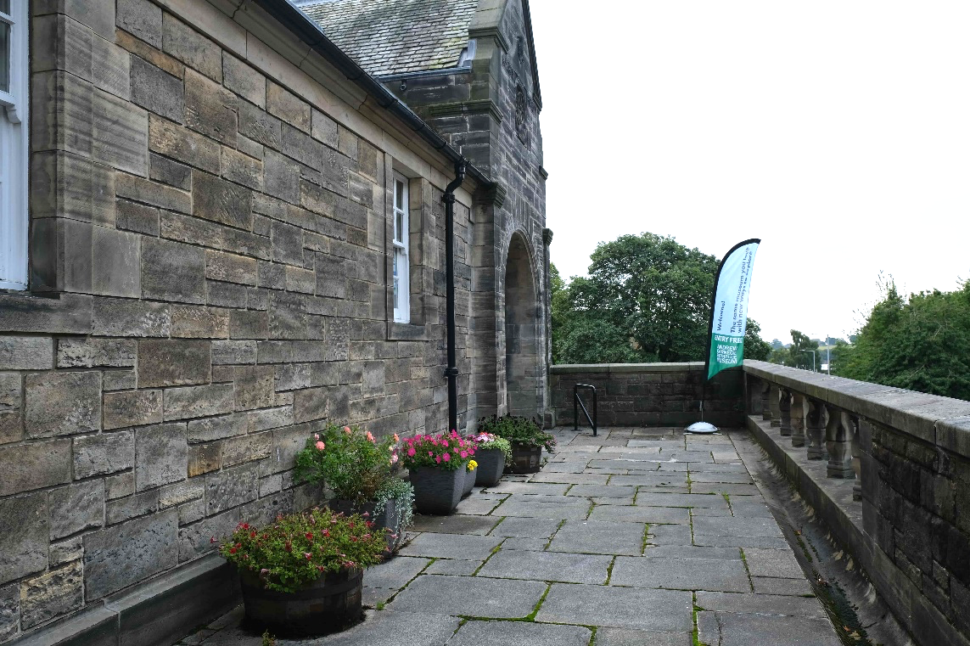
View of terrace taken from the museum’s side gate.

Side Entrance
- Level access to the museum is through side entrance only.
- This entrance is always kept locked for security reasons.
- To enter, ring the low-level doorbell (to the right from the door) and a member of staff will let you in.
- The entrance is 84cm cm wide.
- There are two thresholds (small lip, less than 2.5 cm).
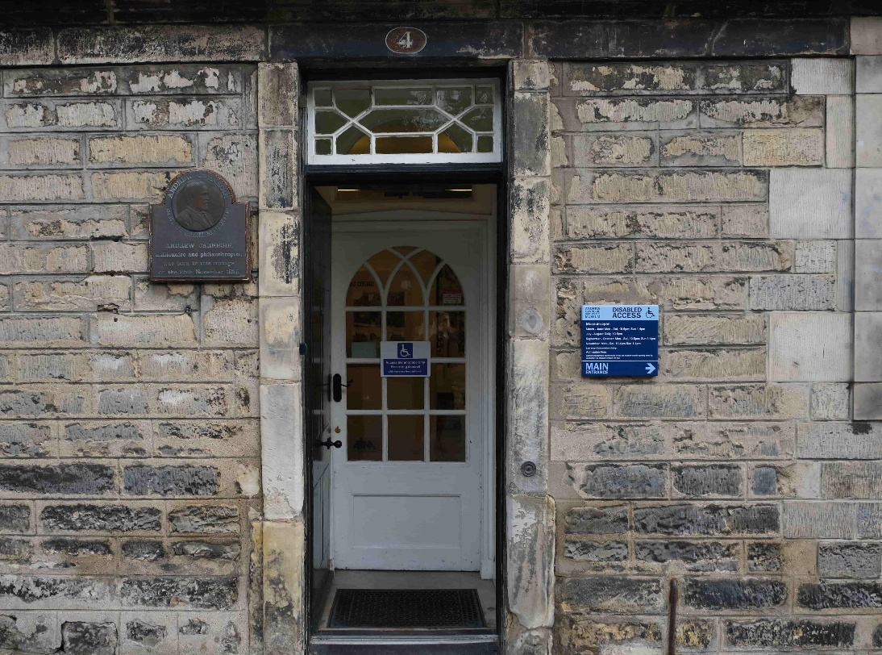
Side Entrance
Doorbell

Reception and Shop Area
- The narrowest point is 150 cm wide.
- The desk has 2 sections of different heights. The higher section is 90 cm high, the lower section is 60 cm high.
- The area is well and evenly lit by ceiling lights.
- There is a hearing loop at the till point.
- Magnifying glass is available, if required.
- Merchandise is displayed on shelves up to a height of 145cm.
Our staﬀ are available to assist customers who require merchandise from the higher level.
- The floor is blue linoleum and on a slight slope, to allow level access between our refreshment area.
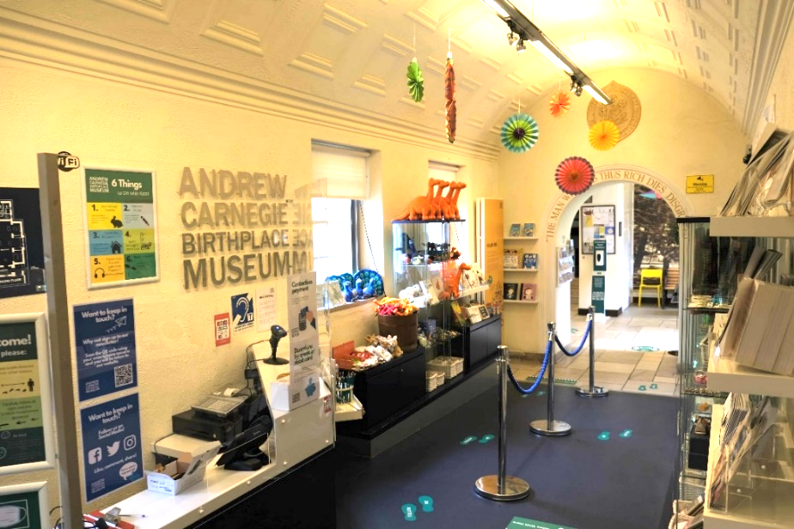
- We have added a clear Perspex screen / sneeze guard to the front desk to protect our visitors and staff. The screen is approximately 190cm from the floor.

View of the museum shop and front desk with new screen.

Who You May Meet - Our Staff

On arrival, a member of staff who will be able to tell you more information about the museum as well as top things to see in the area greets visitors. Our front of house staff now wears a new uniform. They are easily identifiable as they will be wearing blue polo shirts with our museum’s logo, as well as their name tag.
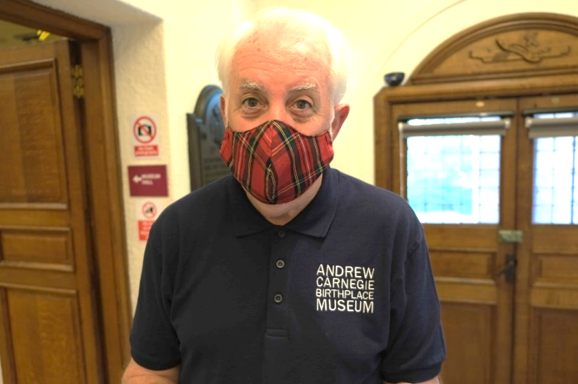
Museum Assistant Ronnie wearing an example of our new uniform.

Most of our staff have received various disability awareness training, as listed below.
Beth – Museum Assistant. Has received Dementia Friendly, First Aid, BSL Awareness and Autism Awareness training.
Ronnie – Museum Assistant. Has received Dementia Friendly, Autism Awareness, BSL Awareness and First Aid training.
Helen – Museum Assistant. Has received Dementia Friendly, Autism Awareness, BSL Awareness and First Aid training.
Gordon – Museum Assistant. BSL Awareness and Autism Awareness training.
Annie – Visitor Services Officer. Has received Dementia Friendly, Autism Awareness, Introductory SignAlong and First Aid training.
Lynsey – Learning and Access Officer. Has received Dementia Friendly, Autism Awareness, British Sign Language Level 2 and First Aid training.
Kirke – Museum Curator and General Manager. Has received Dementia Friendly, BSL Awareness and First Aid training.
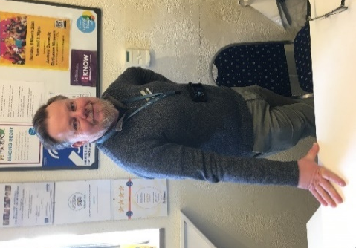
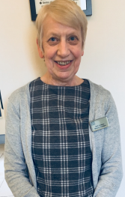
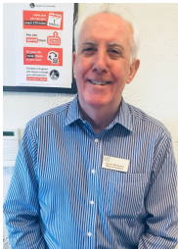
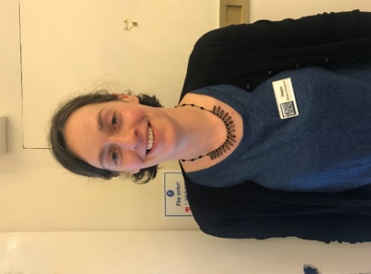
Gordon
Beth
Ronnie
Helen
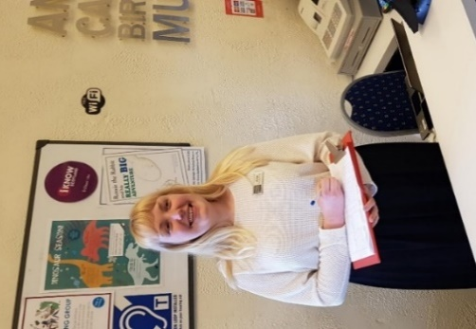
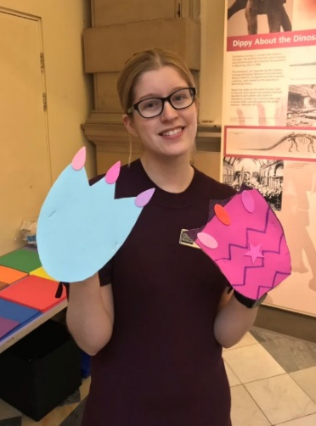
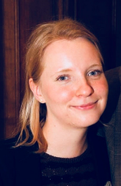
Annie
Lynsey
Kirke

Toilet Facilities
  - In addition to the Gents and Ladies’ toilets, we also have an accessible toilet with baby change facilities.
  - There is level access from the side entrance, through our picnic area and garden to the toilets.
  - Directions to the toilet are marked by large green floor stickers (example below)
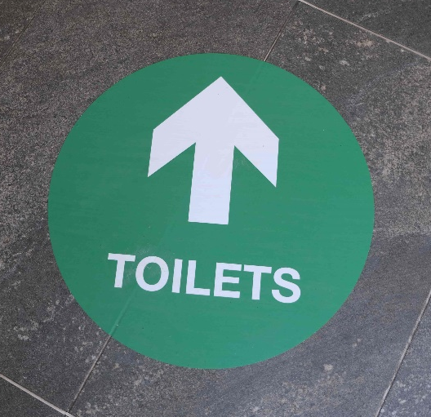
  - The total distance the café door to the toilets is approximately 30 metres. The garden path is on a slight downwards incline.
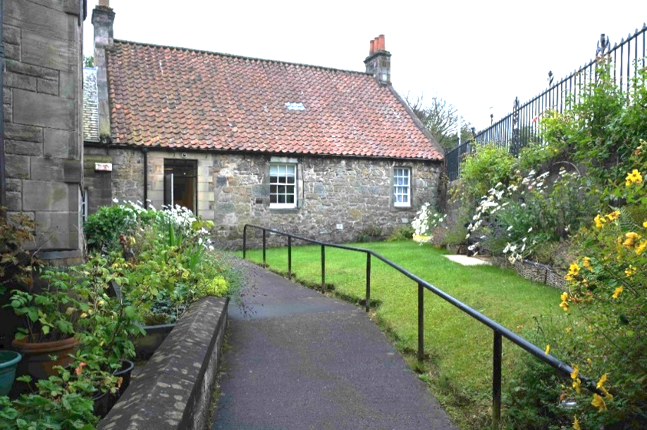
- The door leading to the garden is approx. 90cm wide. The door leading to the toilet block is 80cm wide. The above picture is taken from the toilet block side.

Accessible Toilet Details
- Please note our accessible toilet is not a Changing Places facility.
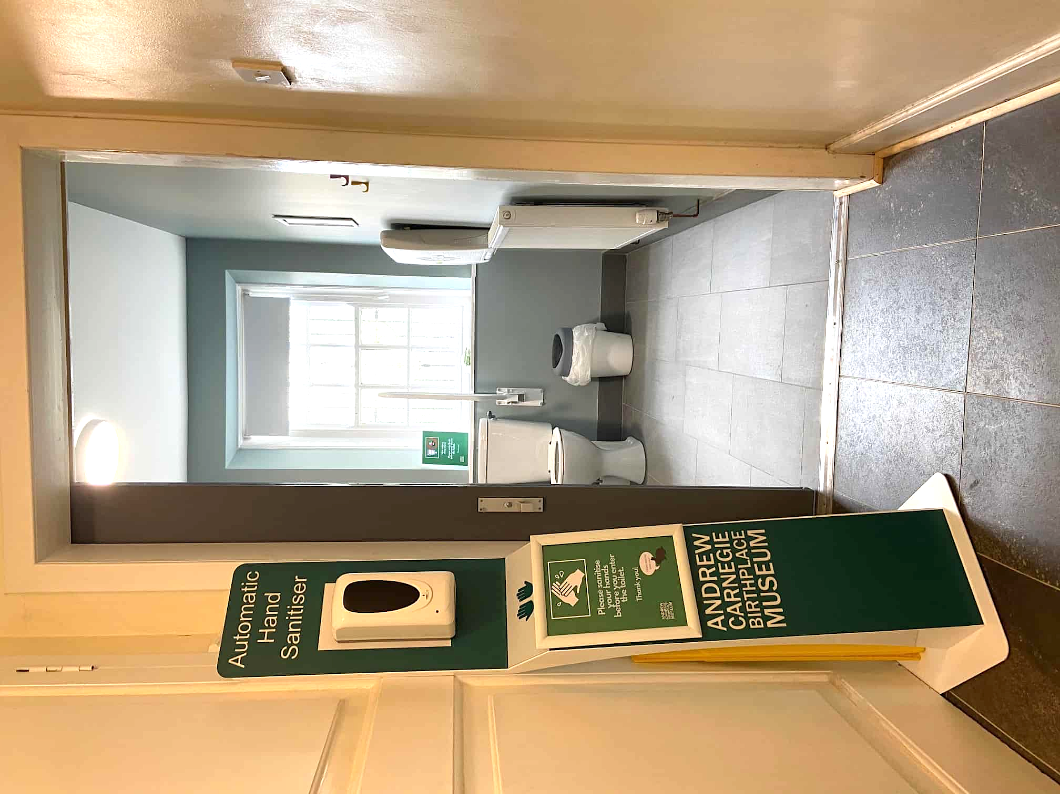
View of accessible toilet door. There is a hand sanitiser station which should be used before entry.
- There is a wall mounted baby change station provided.
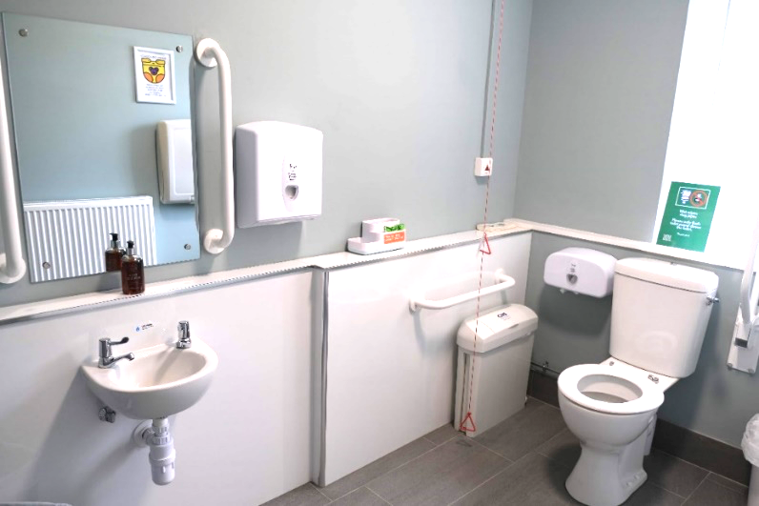
- There is a sanitary waste bin, general waste bin and nappy bin provided.
- The toilet has a light sliding door with tactile braille sign. The doorway is 90cm wide.
  - The toilet floor area measures 255cm by 195cm.
  - The toilet seat is 50cm high from floor, with 185cm space around the front. The toilet has a lever flushing handle.
  - The sink is 70cm high from floor level for wheelchair user access. The tap is a lever tap.
  - There is a horizontal grab rail located on either side of the toilet, approx. 40cm away. The right-hand side rail is secured to wall, the left-hand side rail may be moved up and down.
  - There is an emergency cord with a Euan’s Guide tag reminding visitors to ensure it dangles its full length to the floor and does not become tangled. If activated by accident, visitors can reset it themselves by using the triangular button on the wall. Otherwise, a member of staff will be alerted and come to your assistance.
- To avoid loud noises and sensory triggers, there is no automatic hand dryer in the accessible toilet. There are paper hand towels provided.
- There are grab rails on each side of the mirror. They measure 100cm from the floor.

Garden
- The garden path is paved and has a slight slope downwards to the toilet block.
- There is a handrail along the path (starting 150cm away from the cottage door). The handrail is 80cm from the ground.
- There is a bench in the garden for your convenience.

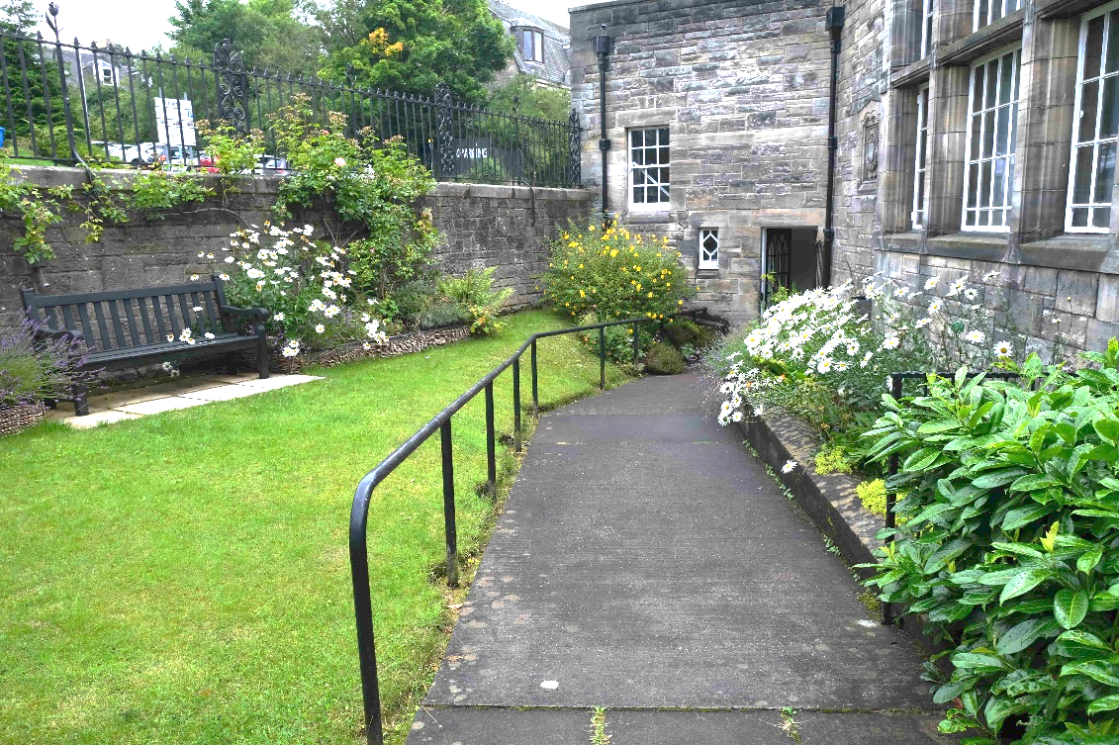
View of garden from indoor refreshment area.

Assistance Dog Facilities
- Assistance dogs are welcome in all areas of the museum.
- The garden is a nice spot to sit outside and rest with your dog.
- Staff can provide a water bowl for refreshment.
- The closest park facility for longer walks is Pittencrieff Park. The closest level access entrance is 320 metres from the museum via Monastery St. The total ascent and descent of this route is 32 feet.

Indoor Refreshment and Play Areas

  - The refreshment area currently has one table and three chairs. Some chairs have arms, some not. There is also a bench and high chair in the kids’ play corner.
  - The seats can be moved to accommodate visitors who need more space. Staff are able to help if required.

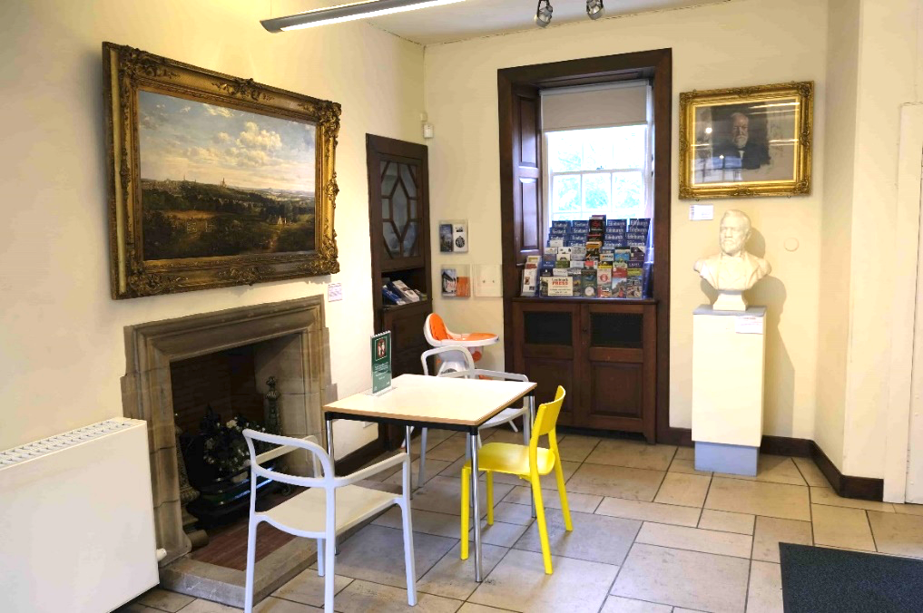
  - There is normally a play corner for children with books, games and explorer backpacks. These activities have been temporarily removed due to Covid 19.
  - Currently out of order There is a vending machine for hot drinks. UHT milk and sugar is available.
  - Drinks and snacks can be purchased from the museum shop / reception.

Visitor Route

The museum operates on a one-way system. We ask visitors to visit the Birthplace cottage first and then continue the Museum Hall.

Birthplace Cottage
- There is no level access to the birthplace cottage rooms.
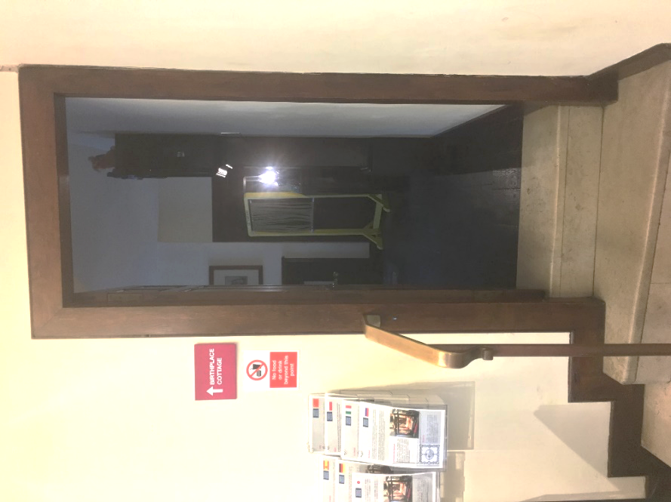
- The doorway to the cottage is 70cm wide (see above). There are three steps to the ground floor.
- Please note that the rooms in the Birthplace cottage have low ceilings and doorways.
- All rooms in the cottage have low lighting.
- The original hardwood floor is made of dark wood and is slightly uneven.
- An audio version of the tour of the rooms and an iPad showing 360-degree view of the rooms is available from reception for anyone who cannot access the cottage, with a folder containing images of each room. This can also be accessed via our website.
- The upper floor is only accessible by a steep set of stairs (15 in total). There is a hand rail.

Cottage Lower Floor
- There are two rooms on the lower floor.
- The front room contains a single display case and one information panel.
- There is a chair in this room for visitors to rest.
- The loom room door is 75cm wide.
- The accessible area in the loom room is 100cm deep.
- The room has text panels.
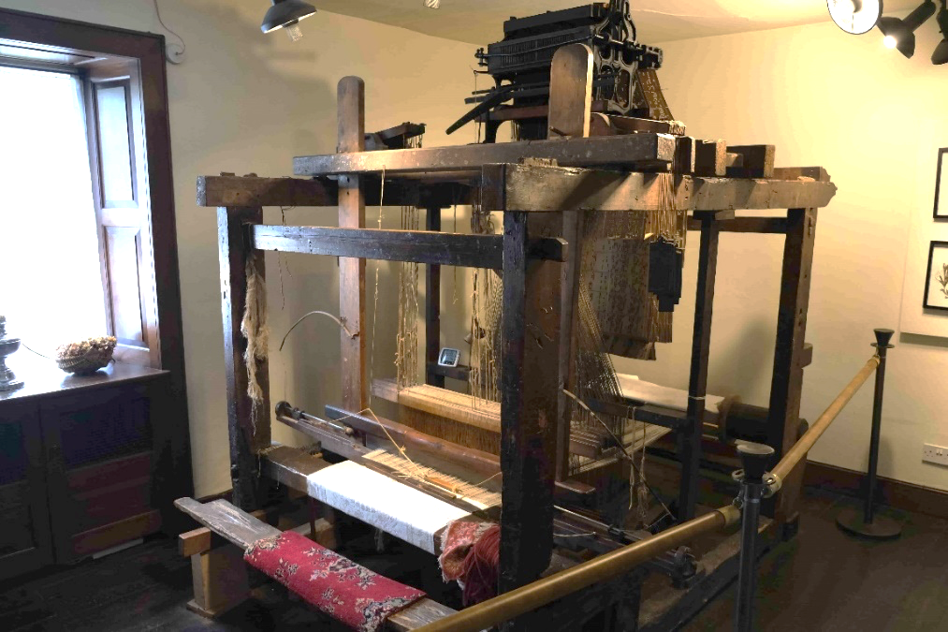
- Automated audio recording of traditional weaving music starts playing when you enter the room. The track lasts 1 minute and plays on repeat. Staff are able to turn it off at request.

View of the Loom Room.

Cottage Upper Floor
- Upper floor is accessible by a set of stairs. Due to the historic nature and age of the building, there is no lift.
- The staircase is 90cm wide and there is a handrail on the right-hand side. There are yellow strips on the edge of the steps to aid visibility. There are 15 steep stairs in total.
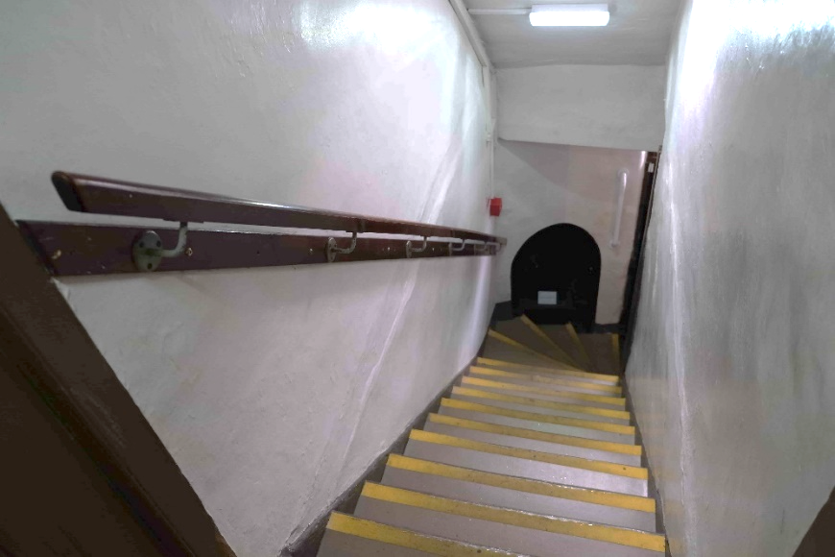
- There are two rooms on the upper floor, joined by a small landing 100cm by 80cm.
Picture of cottage staircase, taken from Birthplace room landing.

Birthplace Room
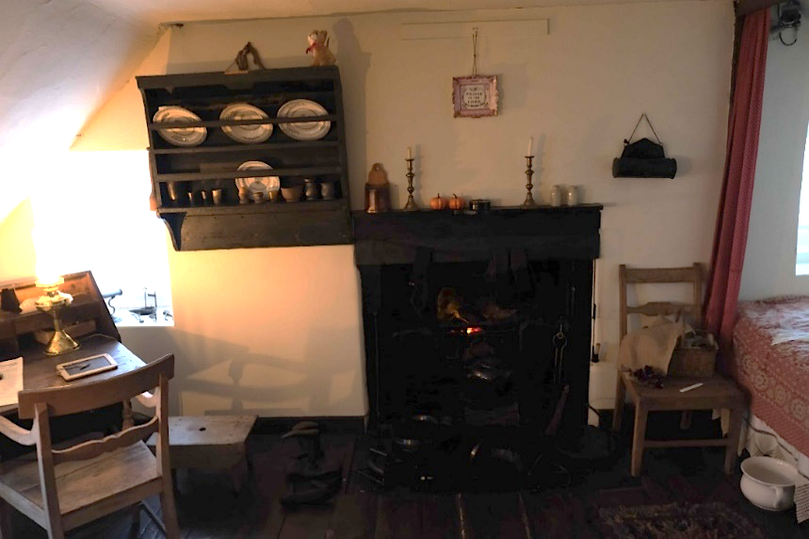
- The first is the Birthplace room, in which Andrew Carnegie was born.
- The original hardwood floor in the birthplace room and stairs is made of dark wood and is slightly uneven.
- The room contains mid-19th century furniture, laid out the way it would have looked like when the Carnegie family lived there.
- Barriers cordon off part of the room. The accessible area is approximately 85cm by 85cm.
- There is a button to the left of the doorway which plays a 3-minute audio recording about the cottage and Andrew Carnegie’s early life in Dunfermline. Once you have pressed the recording, it will play through fully to the end.
- There is no seating available in this room.

- Audio for the Heritage room is displayed on a mounted board. There are two tracks which last about 2 minutes in total. You can use a smartphone device to scan a code and it will play the audio for you. You may need to enter a passcode on your device of 1234 to unlock the audio. A member of staff can assist you if you are unsure what to do.
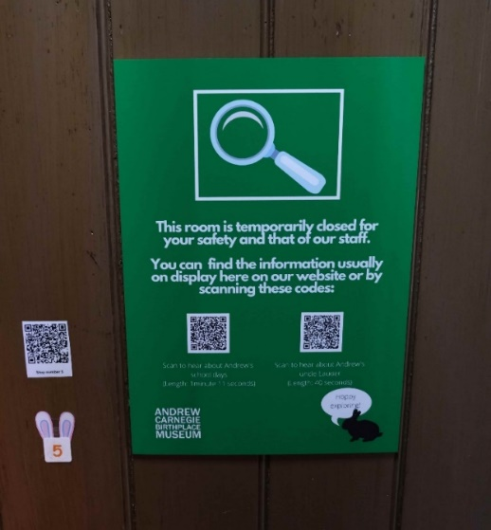
Poster with QR codes on which enable visitors to listen to audio on their own devices.

Heritage Room (please note this room is currently closed)
- The room contains mostly text panels (background information about Andrew Carnegie) and a dressing-up area with some activities for children.
- There is no natural lighting this room, so it is darker than the rest of the museum.
- The room contains a mirror.
- There is a button to the right of the doorway, which plays an audio recording about Andrew Carnegie’s educational background. The audio recording summarises the information on the text panels and lasts 1.40 minutes.
- There is one chair available in this room. There is a small step for children to reach the interactives.

Museum Hall
  - The Museum Hall contains displays about Andrew Carnegie’s life in America, how he made his money and why he gave it away.
  - There is level access to the hall. The door way is 135cm wide.
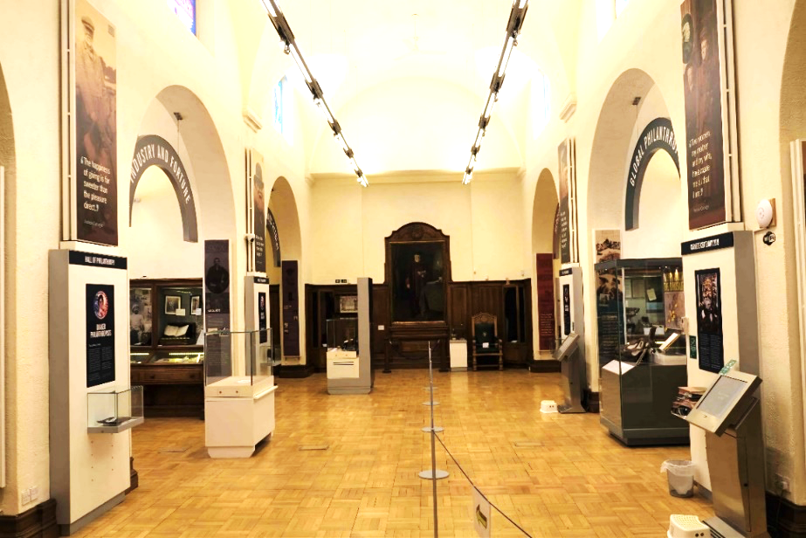
  - There are six alcoves in the hall. Due to Covid 19, we have implemented a one-way system to allow for social distancing and easing the flow of the route. Visitors should visit the alcove displays in chronological order travelling clockwise round the room.
  - There are barriers along the centre of the room with arrow signs reminding visitors to travel in one direction during Covid-19.
  - The display cases are a mixture of wooden wall cabinets and glass floor cabinets. Floor cabinets are up to 2 metres tall. Wooden cabinets are up to 3 metres wide and 85cm tall for the lower cases, 220cm tall for the upper level.
  - Occasionally, there are temporary displays in the centre of the hall, using temporary walling. Minimum of 80cm of space is left between all access routes. Temporary exhibition information will be advertised on our website.
  - There are six video touchscreens in total. There are no subtitles. There is a hearing loop in each station.
  - Two of these screens are mobile touchscreens – one with a short video about Scottish artist Calum Colvin (lasting 1 minute 20 secs) and the other an interactive Carnegie game for kids.

Sensory Triggers

We understand there are many sensory triggers that may sometimes make visitor experiences difficult.
We have a Visual Story for those with additional support needs and their families. This guide highlights various triggers and interactives around the museum. It is available to download on our website alongside other information to read.
We also have an Autism Friendly sensory backpack available (see below) which visitors can borrow for free at request.
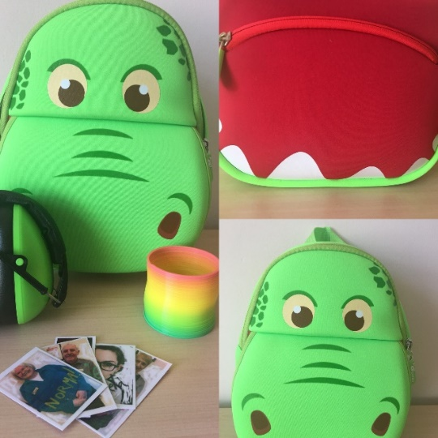
__________________________________________________________________________________________

Emergency Evacuation Procedures

- Fire Alarm tests are carried out during closed hours.
- We have an audible fire alarm only.
- In the case of a sounding alarm, all visitors are required to gather at the bottom of the car park. Please report to the member of staff responsible.
- There is only one level evacuation route, which is the same as the entrance route to the building. (Via the side entrance)
- There are three additional fire exits for those who do not require a level entrance/exit point. Please see the floorplan provided.

